**Brooklyn torah gazette**

**For parshas shoftim 5781**

Volume 5, Issue 52 (Whole Number 252) 6 Elul 5781/ August 14, 2021

**Printed L’illuy nishmas Nechama bas R’ Noach, a”h**

For a free subscription, please forward your request to [***keren18@juno.com***](mailto:keren18@juno.com)

*A Blast from the Past!*

**"Closed for Inventory"**

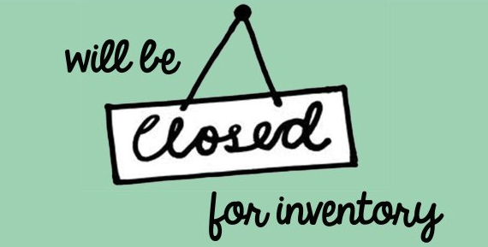

"Closed for Inventory" the sign reads. We all know what that means. The company is taking stock, counting how many widgets and thingamajigs they've sold, how many they still have, what losses or damages they have incurred. And, depending when a particular company's fiscal year starts and ends, that's when inventory is taken. Once all this has been done, correct information is available when filing reports with banks, insurance companies, and the government.

**A Time to be Jolted from Our**

**Lethargy and Complacency**

This coming week starts inventory time in Jewish life. It's the beginning of the month of Elul, the month preceding the High Holidays. And, typically, the month contains many customs to put us in the mood for introspection and jolt us out of our lethargy or complacency.

The alarm clock of Elul is the shofar, blown every morning except for the eve of Rosh Hashana. The prophet Amos said, "Can the shofar be blown in the city and the people not tremble?" In ancient times, the shofar was a call to war. Aside from its yearly use on Rosh Hashana and at the closing service of Yom Kippur, it is also the one sound Jews have longed for endlessly, for it will herald the arrival of Moshiach.

**An Unfortunate Insensitivity to the Message**

That many of us hear the shofar sounded and do not tremble does not denote a lack of power on the part of the shofar to influence us but rather, unfortunately, our insensitivity to its message: "Wake up, you sleepers from your sleep and you slumberers from your slumber. Search your deeds and return in penitence." The shofar is the "air raid siren" for the soul, though we must attune ourselves to it.

Greeting card companies do a burgeoning business during Elul, though the idea of Jewish New Year's cards have their basis in custom, not commercialism. Jewish custom has it that when we see or write to friends and acquaintances, we wish them a "good year," or that they be "written and sealed for good." This greeting is to remind us, and others, that these are days of judgement, when the reckoning of our Heavenly Account is taking place. And just as we ask for mercy for ourselves, we should also ask for G-d's kindness and compassion for our friends and relatives.

**A Time to Try and Increase and**

**Enhance our Performance of Mitzvot**

Lastly, Elul is the time when we especially try to increase and enhance our performance of mitzvot. As thoroughly and scrupulously as we would examine the stockroom and look at each shelf when taking inventory, we must do similarly with our Jewish inventory.

We're supposed to consider what losses and damages others have incurred at our expense, whether we really have all the good deeds in store that we think we have or tell others we have, what mitzvot we need to stock or restock for the coming year. And, thankfully, when taking Jewish inventory, we don't have to close up shop.

*Reprinted from the Parshat Shoftim 5756/1996 edition of L’Chaim Weekly, a publication of the Lubavitch Youth Organization in Brooklyn, NY.*

**Parshas Shoftim: Using Elul Productively**

**Teshuvah is Easy,**

**Change is Difficult**

**By Rabbi Bentzion Shafier**

**Founder of TheSmuz.com**

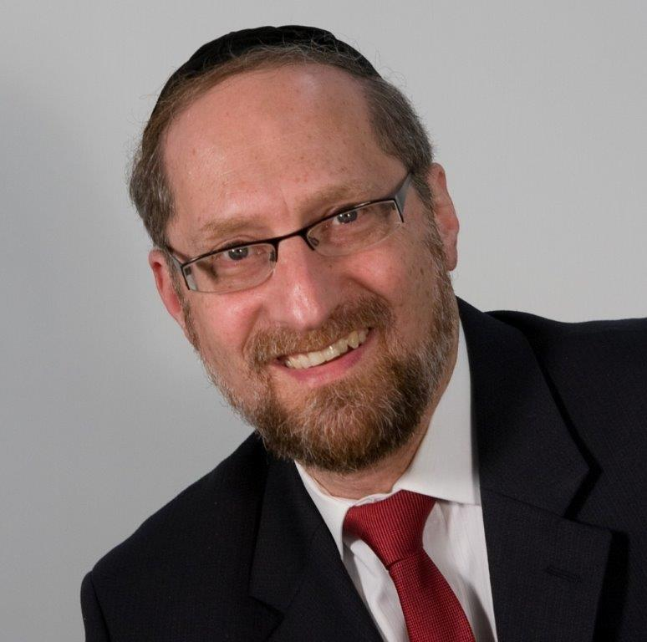

And when Moshe descended from Har Sinai, and the two tablets of testimony were in his hand when he descended from the mountain, Moshe did not know that his skin had become radiant while He [HASHEM] had spoken with him. And Aharon and all of *Bnei Yisrael* saw Moshe, his face illuminated, and they feared approaching him.

Come and see how great the power of sin is! Because when they had not yet stretched out their hands to sin [with the Golden Calf], what does He say? “And the appearance of the glory of HASHEM was like a consuming fire on top of the mountain before the eyes of the *Bnei Yisrael.*” (*Shemos* 24:17) They were neither frightened nor quaking. But since they had made the Calf, even from Moshe’s rays of splendor, they recoiled and quaked.

*“****And Aharon and all of Bnei Yisrael saw Moshe, his face illuminated, and they feared approaching him***.*”* — *Shemos* 34:30

With the entire Nation gathered at the foot of Har Sinai, Moshe Rabbeinu went up to receive the Torah. When he came down forty days later, the Jewish People were in a very different state than when he had left them. Through the influence of the mixed multitude, they were engaged in a form of idol worship. While it’s true that the vast majority of the people didn’t actively engage in the act, for such a people so soon after hearing, “I am HASHEM Your G-d,” directly from our Creator, this was so egregious that it was considered as if they had each participated. The only hope was for Moshe to beseech HASHEM for mercy.

After destroying the Golden Calf, Moshe went back up Har Sinai, spent another forty days with HASHEM, and then He forgave the Jewish People. Then HASHEM told Moshe to go back up a third time, now to reaccept the Torah and bring down a second set of *luchos*.

This time, when Moshe came down his face was illuminated — literally shining from holiness. When the people saw him, they were awed and didn’t dare to look directly at him. From that point on, whenever Moshe went out in public, he wore a veil to hide his face.

Rashi comments that earlier, when HASHEM Himself appeared to the entire nation, everyone — man, woman and child — was able to look at HASHEM. Now even just the reflection of the HASHEM’s glory on the countenance of a man was more than they could handle. From here we see the damage of sin.

This Rashi is difficult to understand. Moshe came down the final time on Yom Kippur. For generations, that day has been set aside as a day of forgiveness because HASHEM forgave the sin of the Golden Calf. And even more, Moshe immediately commanded the Jewish People in the *mitzvah* of building the *Mishkan* (tabernacle). This was to be a permanent sign that HASHEM forgave the Jewish nation. Clearly, the sin was forgiven, so why couldn’t the Jews look at Moshe’s face?

The answer to this can best be understood with a *moshol*.

**The Judge Can Forgive Him**

Imagine a man who, after having a few too many drinks, gets into his car and begins driving. It takes a while before he is pulled over, but finally, the police arrest him, and he stands trial for driving while intoxicated. Understanding the gravity of the charges, he makes a heartfelt appeal to the judge. “Your honor, what I have done is wrong, and there is no excuse. I endangered the lives of others as well as myself, and there is no defending my conduct. I cannot express my shame and regret for my actions. However, it is a first offence, and I am a family man, and community-minded. I beg the court to have mercy.”

If the man is convincing, and the circumstances support him, the judge may forgive him and waive the charges, in which case the offense is stricken from the record, and he is the same as he was before the fateful event happened.

But what if when he got behind the wheel of his car, and instead of being pulled over by the police, plowed into a telephone pole? By the time the paramedics get to the scene, it looks bleak. As a last measure, a helicopter flies him to the nearest hospital, but there is nothing that could be done. His spinal cord is severed, and he is paralyzed from the waist down.

In this case, if he were to stand trial for drunk driving, the judge may forgive him, and his record may be clean, but the damage is still there.

This seems to be the answer to Rashi. The Jewish Nation did *teshuvah* and were forgiven. But the world was still changed. At that pivotal moment in time, for the Exalted Nation to engage in something akin to idol worship changed the very spiritual dimensions of the world. Yes, they were forgiven for what they did, but they weren’t the same as they were before, and neither was the rest of Creation.

**Teshuvah Isn’t Enough**

This concept is very applicable to us. On Yom Kippur, we are charged with the *mitzvah* of *teshuvah*. *Teshuvah* involves four parts: separating from the sin, regret, confession, and a plan not to repeat the offence. But there is still more work to be done. I have to repair the damage done.

If over the past year, I haven’t learned properly, I can ask HASHEM to forgive me for my lack of diligence, but I still remain lacking. It’s up to me to now fill in what I have lost. If I have had words with relatives of friends, it’s not enough to ask forgiveness. That takes care of the actual sin. But the repair of the relationship still has to be done. And certainly in terms of the way that we treat our spouses, while we will ask forgiveness, and can expect it to be granted, the real work is looking forward and asking ourselves, “What can I do to make my marriage better?”

*Teshuvah* can eliminate the sin and make it as if it never happened, but it can’t make up for the lost opportunity. That can only happen with a course correction, accomplished with careful analysis of how we spend our time and asking ourselves the critical question: am I happy with the direction of my life?

*Reprinted from the current website of TheShmuz.com*

**Rabbi Berel Wein on**

**Parshat Shoftim**

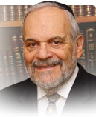

This week's Torah reading envisions for us an efficient, organized system of law and order, justice, and fairness. The Torah set a very high bar regarding the selection of judges and police. They are to be free of prejudice, bias and personally held agendas and social ideals. They are literally to be blind, without knowledge as to the nature and personalities of the litigants who appear before them and whose cases they must decide. The judges must be free of any form of corruption, from open graft to simple courtesy.

The Talmud records for us that the great Mar Shmuel, the head of the Academy of third century, Nehardea in Babylonia, was walking across a narrow bridge when the person coming towards him honorably made way so that the Rabbi could pass. Later in the day, this very same person appeared as a litigant before Mar Shmuel in a case before his court. Afraid of being influenced by the courtesy extended to him by this person, by allowing him to pass first on the narrow bridge, Mar Shmuel disqualified himself from judging the matter.

While such standards of justice that are outlined in this week's reading are almost impossible for human beings to achieve, we all are influenced by great and small things that occur to us, and by previous prejudices that have been instilled into us by events and societies. Though justice may be blind, the justices themselves rarely, if ever, are able to obtain the necessary level of fairness that the Torah seems to demand. Yet, we are aware that the Torah was not granted to angels, but rather, to human beings, and human beings are never perfect and always have, within themselves, prejudices and preconceived ideas regarding policies and judgments.

The Torah set standards for us to try and achieve. It never demands the impossible from human beings. So, the requirements set forth in this week's reading are the goals that we must try to achieve. We must pick the best, wisest, least prejudice, most honest people of integrity, that we can find in our midst, and appoint them as judges and police. Yet, the Torah reminds us that ultimate justice belongs to the Lord.

Mistakes that we make here on earth, in the long run of time and eternity, are always rectified by Heaven. We should be comforted by this. The Talmud teaches that a judge can only judge what he sees and understands, with the human condition appearing before him. Heaven, however, has the ability to see everything, in terms of eternity, in terms of ultimate justice and fairness to all. It is without limited knowledge, therefore, that we are to do our best, and realize that ultimate justice is not done here on earth, but, rather, subject to the guidelines of Heaven. We can only attempt to create the best system of justice that is possible, within the constraints of human behavior and society.

*Reprinted from the current website of rabbiwein.com*

**The Spiritual**

**Cities of Refuge**

**From the Talks of the Lubavitcher Rebbe**

**Rabbi Menachem Mendel Schneerson, Zt”l**

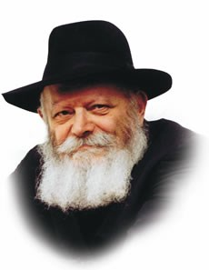

This week's Torah portion, Shoftim, speaks about the cities of refuge a person would flee to if he accidentally killed someone. There, the unintentional killer would dwell, protected from the wrath of the victim's relatives, until the High Priest who served in the Holy Temple passed away.

But not only unintentional killers sought refuge in these cities; even someone who committed murder intentionally was expected to flee there as well. The court would then convene and issue its ruling on the death. The cities of refuge offered protection, if only temporarily in some cases, to anyone who had caused a loss of life.

**The Eternal Torah and Its**

**Lessons in Every Generation**

After the destruction of the Holy Temple and the dispersion of the Jewish people, the cities of refuge ceased to exist in the physical sense. Yet the Torah is eternal, and its lessons apply in every generation. In our times, therefore, the concept of "cities of refuge" finds expression in the spiritual dimension.

Our Sages taught that "the words of Torah absorb." In other words, the Torah itself is the refuge in which all may seek asylum. In the spiritual sense, "killing" symbolizes the act of committing a sin, causing a spiritual death to the G-dly soul, for the Torah's 613 mitzvot are the "ropes" that bind the soul to G-d. Transgressing the Torah's commandments damages those ties and threatens to cut the soul off from its G-dly source.

**It is Never Too Late to Repent**

We learn from this week's Torah portion that it is never too late to repent, no matter how grave a transgression has been committed. Even the person who deliberately sinned can do teshuva (repentance) and seek protection in the refuge of Torah.

In one sense, nowadays we have a distinct advantage over our forefathers who lived during the times of the Holy Temple. In those days, repentance alone was not enough to atone for a sin. The unintentional killer had to remain exiled in the city of refuge until the death of the High Priest, and the intentional murderer (as defined by the Torah) received capital punishment. Yet after the destruction of the Temple, teshuva alone can atone for even the gravest sin.

**G-d Can Look into the Heart of Man**

Years ago, when Jewish courts had ultimate authority, a judge could only rule on what he himself had seen. G-d, however, can look into the heart of man and judge whether or not his repentance is sincere.

In the same way, the month of Elul, during which we take account of our actions of the previous year, is a "city of refuge" in time, offering us the same opportunity to clear the slate and merit a good and sweet year to come.

*Reprinted from the 5756/1996 Parshat Shoftim edition of L’Chaim Weekly. Adapted from the works of the Lubavitcher Rebbe.*

# Rav Avigdor Miller on

# Saying ‘LeDovid Uri”



**QUESTION:** **Why do we say לדוד השם אורי in Chodesh Elul?**

**ANSWER:** Chodesh Elul is a month when you must prepare.  You can’t just walk in before the melech and say, “Here I am. Judge me.”  You have to have hachanah l’Yom Hadin; you need to prepare for the Day of Judgement. And this mizmor speaks about the mora hadin, about the awareness and fear you should prepare yourself with.

Now, when you mention mora hadin the first thing you have to know is that Hashem must be your אורי וישעי. It means that Hashem is אורי, my light, my seichel. You’re thinking about Him and He illuminates your mind; your entire way of looking at the world is guided by the light of thinking Hakodosh Boruch Hu’s thoughts. And because of that you know that  ישעי – He’s my salvation; it means that you know that whatever happens to you, He’s doing it for your benefit.  It’s all for your good.

You need both things: He’s אורי – He illuminates my seichel, and ישעי – I know that the ma’asim that He gives are for my benefit. Only then could you say, ממי אירא – how could I be afraid?  You have to work on that. You have to work on Hashem being אורי וישעי, that you think about Him always and that you know that He’s doing everything and that it’s all for your benefit. Then you can say, “I’m not afraid.” It’s mashma that otherwise you should be afraid; unless you have some reason to justify your confidence you have to be afraid of the Yom Hadin.  
 And therefore that mizmor speaks about what we have to be afraid of. It mentions constantly that we’re surrounded by enemies and the yetzer hora is a very big enemy; it’s the biggest enemy we have to worry about because constantly the yetzer hora is surrounding us.

And so this mizmor reminds us we’re in a month where we have to be ready to fight off the yetzer hora and make preparations for the Yom Hadin.  If I had time, I would take a siddur and go through the whole mizmor but in general that’s the idea.

*Reprinted from the August 9, 2021 email of Toras Avigdor. Adapted from Tape #E-123*

**Inspiring Video Interviews by Rebbetzin Chani Weisberg**

**By Daniel Keren**

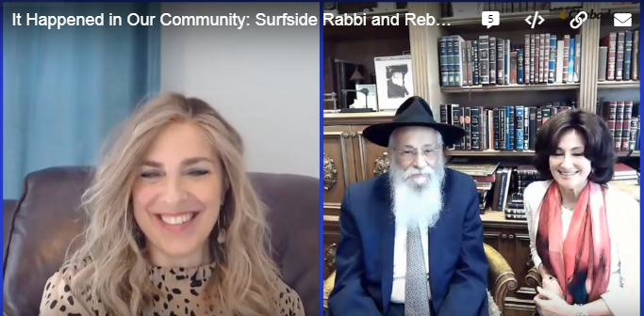

**From right to left: Rebbetzin Chana Weisberg, Rabbi & Rebbetzin Lipskar**

In response to the recent shocking and tragic collapse of the Champlain Towers South beachfront condominium on June 23rd in the Miami suburb of Surfside, Florida, I started checking out various Jewish websites as many of the victims were Jewish.

One item that caught my attention was a 54:42 minute video interview (It Happened in Our Community – Surfside Rabbi and Rebbetzin Lipskar) by Rebbetzin Chani Weisberg of Rabbi Sholom and Rebbetzin Chani Lipskar of The Shul of Bal Harbor which because of its close location to the doomed condominium knew many of the victims who were killed.

**Those Who Lost Everything They Owned**

At the time the interview was conducted about a week after the collapse, there was still hope that some of those in the collapse might still be rescued. Part of the interview focused on how challenging it was to deal with families of the victims and how the entire community was coming together in an incredible manner to help out with meals and other related assistance. Those who were fortunate to not be in the condominium when the 12-story building collapsed literally lost everything and the Shul of Bal Harbor was a location for new clothes and other important items that were generously being offered to those who had just the clothes on their back.

Rebbetzin Weisberg who along with her husband and six children live in her hometown of Toronto, Ontario also asked the Lipskars of the difficult challenge involved in creating the Shul of Bal Harbor back in 1981 when many of the Jews in that area were hostile to the coming of a Chassidic couple that stuck out almost like a sore thumb so-to-speak.

**The Challenge of Making a Minyan**

**In the Florida During the Summer**

Rabbi Lipskar told of how in the winter many out-of-town visitors come to escape the cold. So in the summer it sometimes became in the early years of the Shul a very difficult challenge to get a Minyan during the week. Once there were nine men and the rabbi went out to try and find a tenth Jew.

He saw an old man passing by and stopped him to ask if by any chance he was Jewish. The man barked back at him “What does it matter to you? Why are you bothering me?”

The rabbi explained that he needed a tenth Jew to help make a Minyan and the old man snarled that he wasn’t religious and didn’t believe in religion and that he was going to get breakfast.

When the rabbi returned to his shul he realized that some of the men couldn’t continue to wait so he went out again looking for that old man and tracked him down to a nearby restaurant and saw that his prospect had a plate of bacon and eggs. He put down $5 and pleaded with the man to help make his Minyan. The non-religious Jew was impressed by the fact that the Minyan was so important that the rabbi was willing to pay for his breakfast. The rabbi told Rebbetzin Weisberg that this was the first [and hopefully last] time that he ever would have to pay for a bacon and egg breakfast.

**The Old Man Had a Snarling Presence**

The old man continued to argue that he wasn’t religious and didn’t know what to do; but Rabbi Lipskar assured that they just needed his warm body. And the man came. He continued to come and continued to be a snarling presence in the Minyan. The president of the Shul once pulled aside Rabbi Lipskar and asked him, “Why are you wasting your time with that nasty non-religious Jew?” The rabbi responded that we need him for the Minyan.

In time that old snarling man became a baal teshuvah and before he passed away he called the rabbi to his home and gave him all of his bank passbooks and a will donating them to the Shul. It added up to a million dollars and helped the new Shul expand.

Rebbetzin Weisberg is a dynamic member of the worldwide Chabad community and many of her subjects for interviews are either shluchim (emissaries of the late Chabad Rebbe or charismatic baalei teshuva or converts.

**Debunking the Myths of Orthodox Life**

Other recent and fascinating video interviews by Rebbetzin Weisberg that you might enjoy view or listen to are the video “Debunking the Myths of Orthodox Life” that is particularly appropriate to send to anybody who might unfortunately be thinking of viewing the awful and definitely misleading new Netflix series “My Unorthodox Life.”

Other equally intriguing videos include “Suicide Prevention – In Conversation with Chana”; “Jews by Choice, Not by Birth,” an interview with a bi-racial couple; “A Chinese Girl’s Journey to Judaism – A Dream Come True”; “One Couple’s Fight for Their Baby’s Life”, “What Would You Do if You Weren’t Afraid.”; The Boxing Champion Who Wouldn’t Fight on Shabbat,” and “From Rapper to Rabbi.”

All of these video interviews by Rebbetzin Chani Weisberg are approximately one hour in length. You can google them by their title and by adding “- Conversation with Chana” Even if you are not a committed Chabad fan, you will be impressed by these interviews on important topics. Rebbetzin Weisberg is also a prolific author of books on the woman’s role in Judaism and is the editor of The JewishWoman.org and is a popular international speaker.

*Reprinted from this week’s edition of The Jewish Connection.*